**KAFKA INSTALLATION ON LOCAL MACHINE**

**Tutorials:** <https://www.youtube.com/watch?v=D7IY_CwXUKc&list=PLIRnO_sdVuEf1Ao9hnE9G8c0WHd0MbsOk>

<https://www.youtube.com/watch?v=3XjfYH5Z0f0>

**url to download :**

<https://kafka.apache.org/downloads>

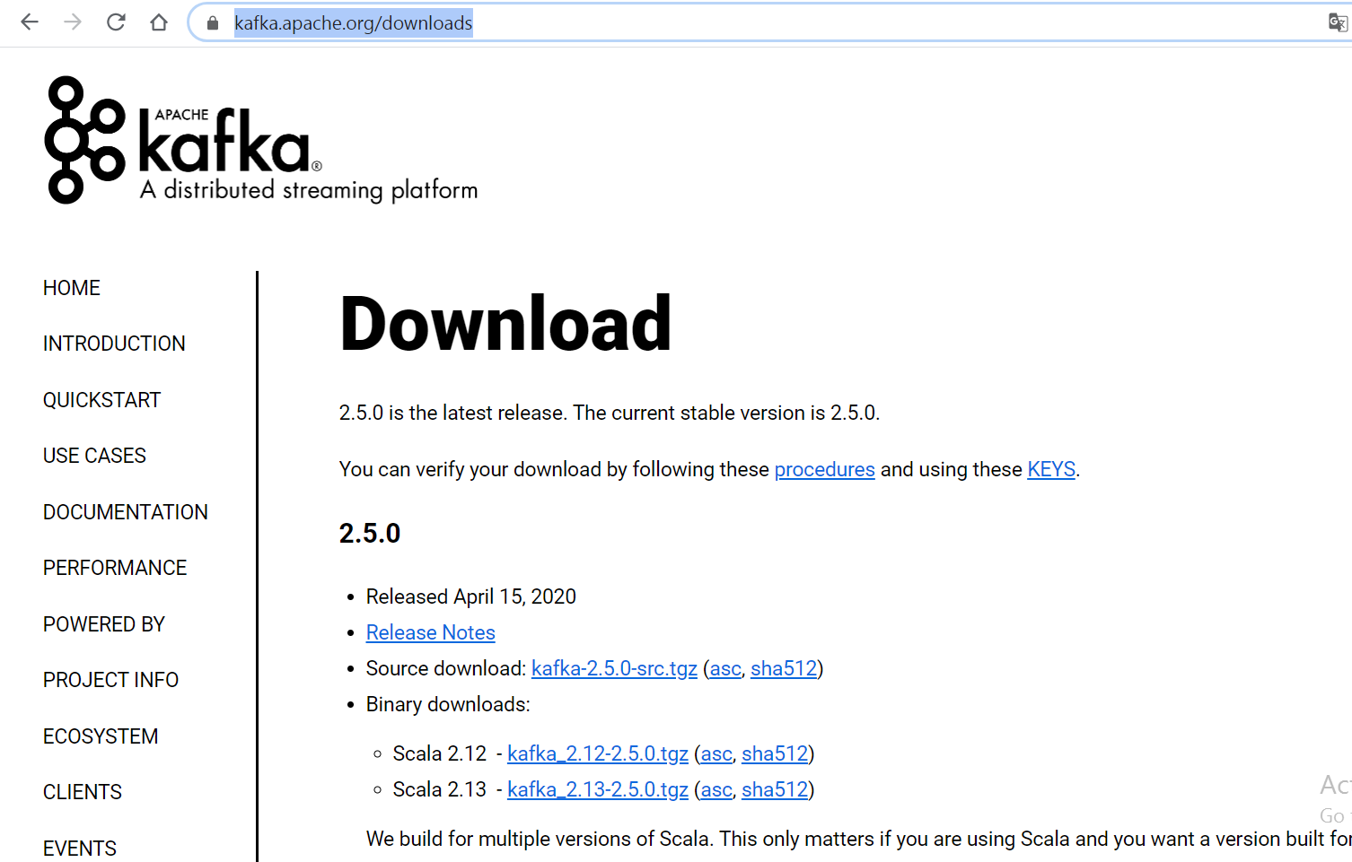

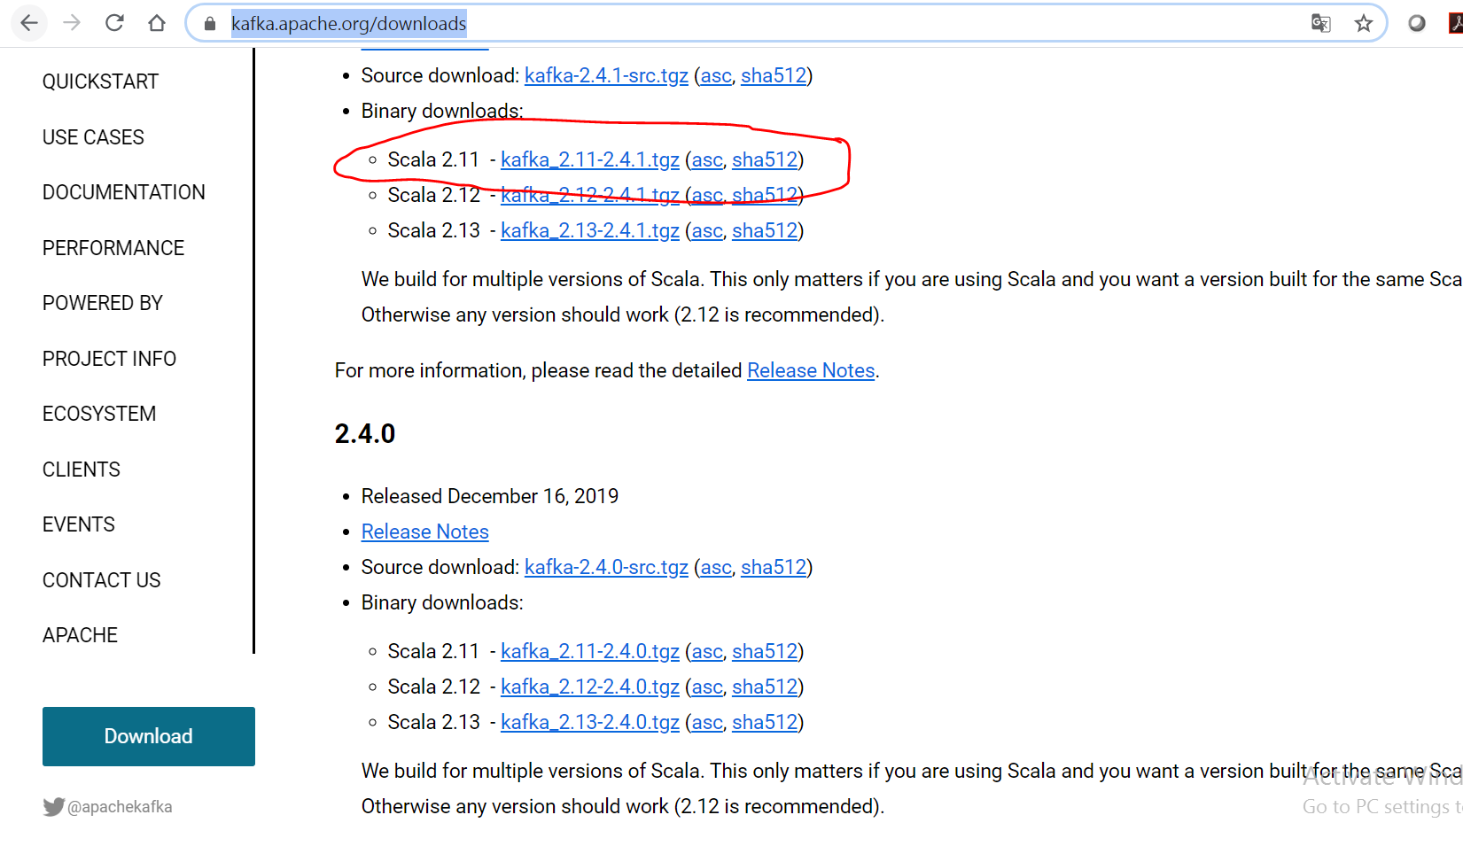

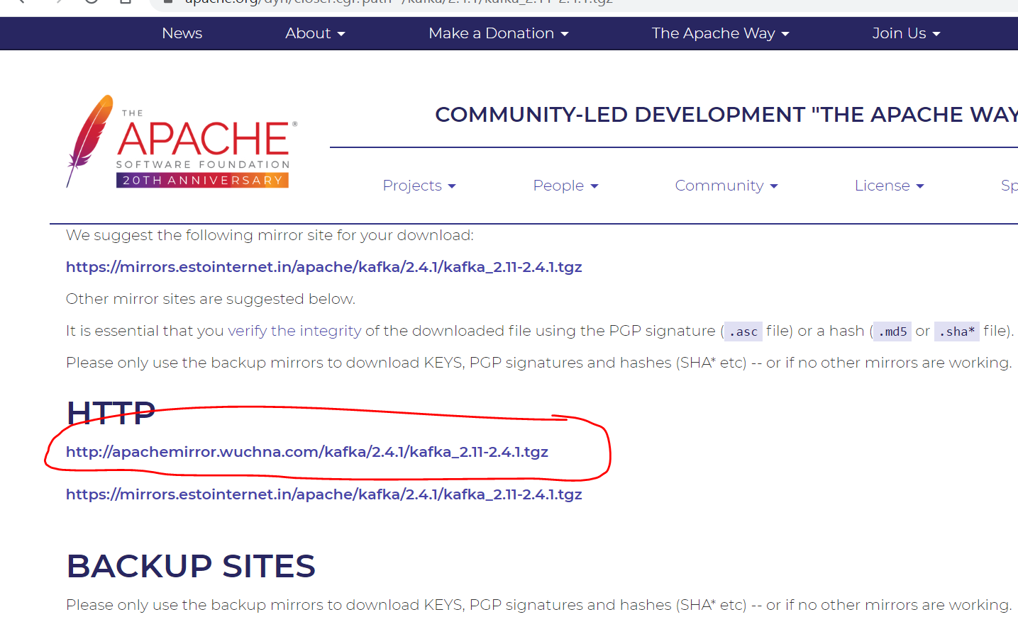

**Move to a folder from download folder.**

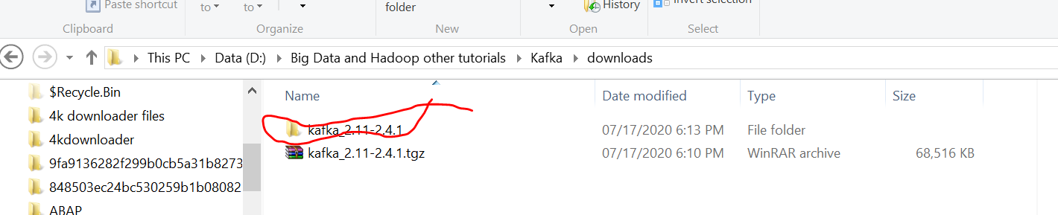

**Unzip the folder .**

**We find the executable files in the bin folder.**

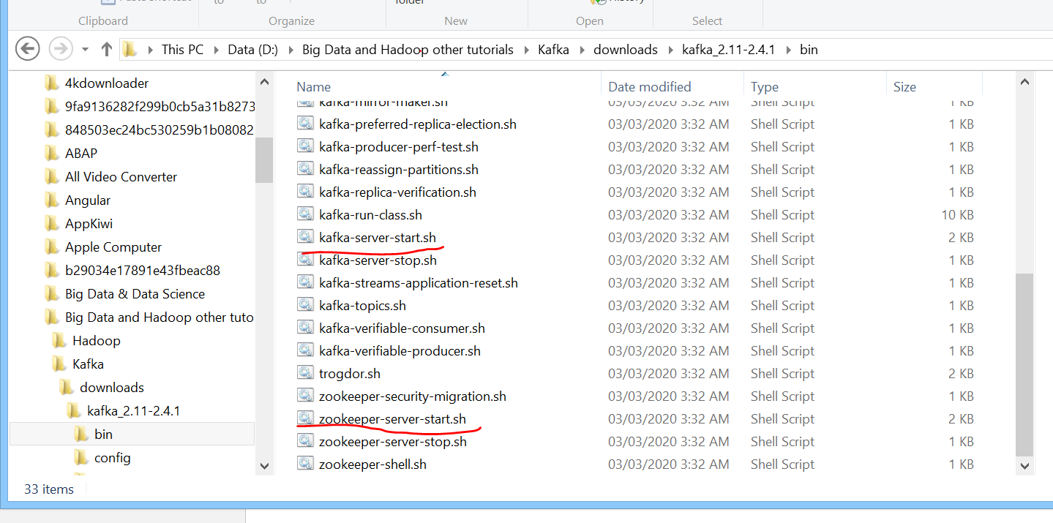

**5 steps:**

1. **Start zookeeper**
2. **Start Kafka**
3. **Create Topic**
4. **Producer Program**
5. **Consumer Program**

**Start Zookeeper**

**D:\Big Data and Hadoop other tutorials\Kafka\downloads\kafka_2.11-2.4.1>bin\windows\zookeeper-server-start-bat config\zookeeper.properties**

**If path variable is not set then , bat files ( extenal commands may not work ).**



******* Make sure you cut the folder and place in directly C Driver. **************

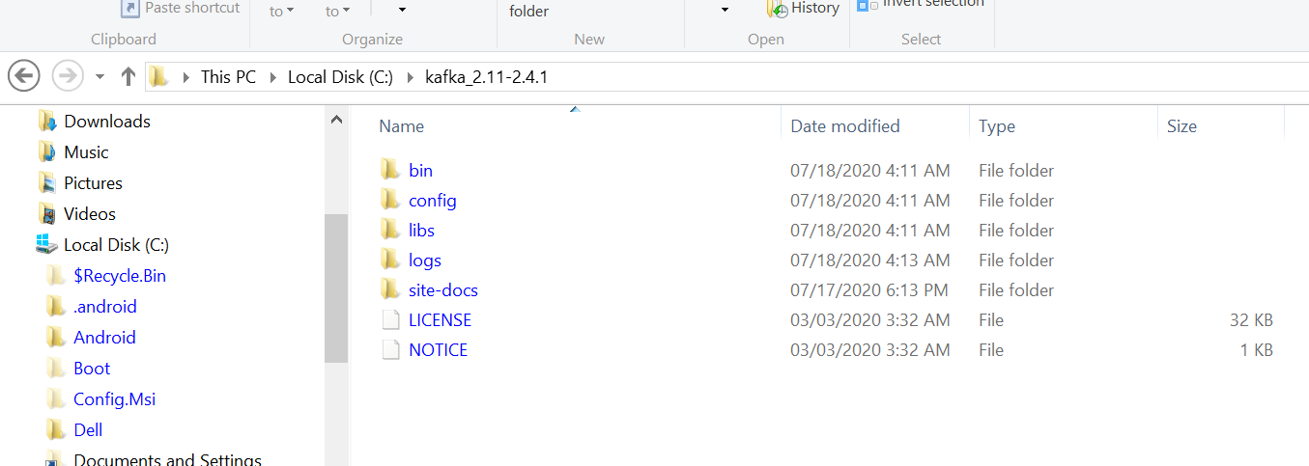

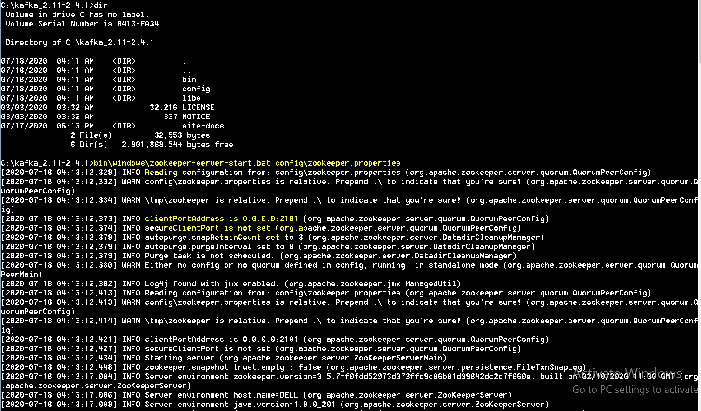

Started on port : **2181**

**Start kafka**

**C:\kafka_2.11-2.4.1>bin\windows\kafka-server-start.bat config\server.properties**

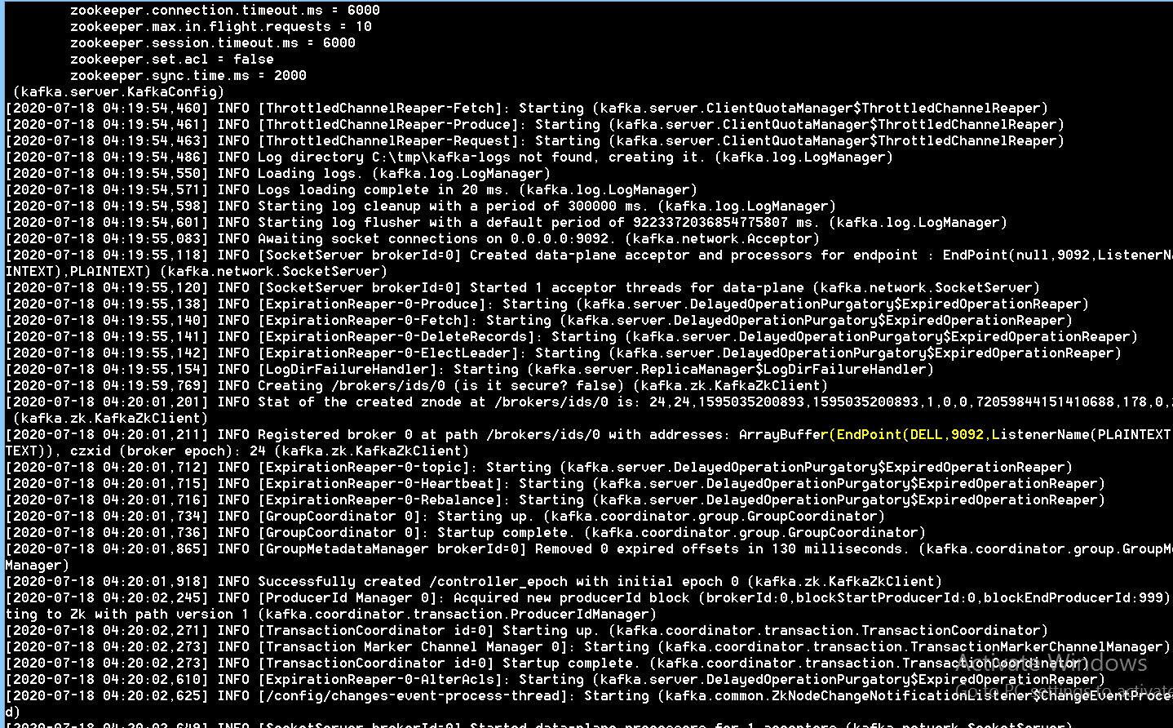

**Port no: 9092**